**1.a. Create the tables with the appropriate integrity constraints**

1.create table customer(cust_id int primary key,customername varchar(100));

2. create table item (item_id int primary key,itemname varchar(100),price int);

3. create table sale1 (bill_no int primary key,bill_date date,cust_id int,item_id int,qty_sold int,foreign key(cust_id) references customer(cust_id),foreign key(item_id)references item(item_id));

**Insert around 10 records in each of the tables**

**mysql> insert into Customer1 (cust_id, customername) VALUES (1, 'John Doe'),(2, 'Jane Smith'),(3, 'Alice Johnson'),(4, 'Bob Brown'),(5, 'Charlie White'),(6, 'David Black'),(7, 'Eva Green'),(8, 'Frank Blue'),(9, 'Grace Pink'),(10, 'Hank Gray');**

**mysql> insert into item1 (item_id, itemname, price) values (1, 'Laptop', 1000),(2, 'Smartphone', 800),(3, 'Tablet', 600),(4, 'Monitor', 300),(5, 'Keyboard', 50),(6, 'Mouse', 30),(7, 'Printer', 150),(8, 'Camera', 500),(9, 'Headphones', 120),(10, 'Speaker', 200);**

**mysql> insert into sale1 (bill_no, bill_date, cust_id, item_id, qty_sold) values (1, '2024-08-19', 1, 1, 2),(2, '2024-08-19', 2, 2, 1), (3, '2024-08-18', 3, 3, 3),(4, '2024-08-18', 4, 4, 1),(5, '2024-08-19', 5, 5, 4),(6, '2024-08-17', 6, 6, 2),(7, '2024-08-19', 7, 7, 1),(8, '2024-08-16', 8, 8, 3),(9, '2024-08-15', 9, 9, 2),(10, '2024-08-19', 10, 10, 1);**

**c. List all the bills for the current date with the customer names and item numbers**

**mysql> select s.bill_no,c.customername,s.item_id from sale1 s join customer1 c on s.cust_id=c.cust_id where s.bill_date=2024-08-19;**

**Description:**

**[**This SQL command retrieves the bill number, customer name, and item ID for all sales made on the current date by joining the Sale table (s) with the Customer table (c) based on the matching cust_id.]

**output:5 rows in set (0.04 sec)**

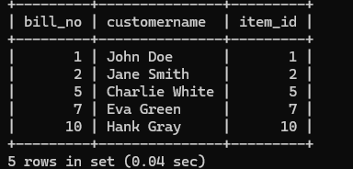

**d. List the total Bill details with the quantity sold, price of the item, and the final amount**

**mysql>**

**select s.bill_no,c.customername,i.itemname,s.qty_sold,i.price,(s.qty_sold * i.price) as amount from sale s join customer c on s.cust_id=c.cust_id join item i on s.item_id=i.item_id;**

**Description:**

This SQL command retrieves detailed information for each sale, including the bill number, customer name, item name, quantity sold, item price, and the total amount (calculated as quantity sold * price) by joining the Sale, Customer, and Item tables based on their respective IDs.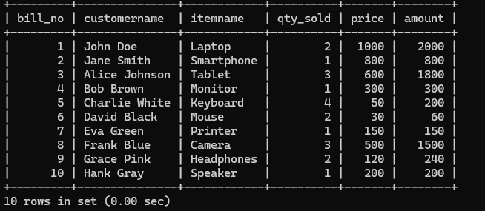

**e. List the details of the customer who have bought a product which has a price > 200**

**mysql> select distinct c.cust_id,c.customername from sale s join customer c on s.cust_id=c.cust_id join item i on s.item_id=i.item_id where i.price**

**>200;**

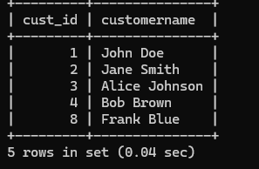

**Description:**

This SQL command retrieves a list of unique customers who have purchased items priced over 200 by joining the Sale, Customer, and Item tables based on their respective IDs.

**f. Give a count of how many products have been bought by each customer**

**mysql> select c.cust_id,c.customername, count(s.item_id)as products_bought from sale s join customer c on s.cust_id=c.cust_id group by c.cust_id,c.customername;**

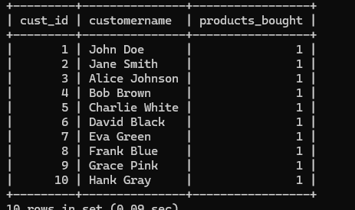

**Description:**

This SQL command retrieves the customer ID, customer name, and the total number of products each customer has bought by joining the Sale and Customer tables, and then grouping the results by customer ID and name.

**g. Give a list of products bought by a customer having cust_id as 5**

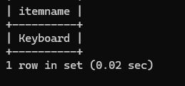

**Description:**

This SQL command retrieves a unique list of item IDs, item names, and prices for items that were sold on the current date by joining the Sale and Item tables.

**h. List the item details which are sold as of today**

**mysql> select distinct i.item_id,i.itemname,i.price from sale s join item i on s.item_id=i.item_id where s.bill_date=current_date;**

This SQL command retrieves a unique list of item IDs, item names, and prices for items that were sold today by joining the Sale and Item tables.

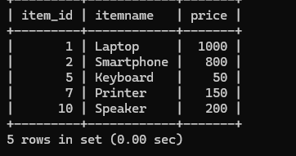

**Lab2**

1.Student (Stud_no : integer,Stud_name: string) Membership (Mem_no: integer,Stud_no: integer) Book (book_no: integer, book_name:string, author: string)Iss_rec(iss_no:integer, iss_date: date, Mem_no: integer, book_no: integer)

For the above schema, perform the following

* 1. Create the tables with the appropriate integrity constraints
  2. Insert around 10 records in each of the tables
  3. List all the student names with their membership numbers
  4. List all the issues for the current date with student and Book names
  5. List the details of students who borrowed book whose author is CJDATE
  6. Give a count of how many books have been bought by each student
  7. Give a list of books taken by student with stud_no as 5
  8. List the book details which are issued as of today
  9. Create a view which lists out the iss_no, iss _date, stud_name, book name
  10. Create a view which lists the daily issues-date wise for the last one week.

1. a**. Create the Tables with Appropriate Integrity Constraints**

CREATE TABLE Student2 ( Stud_no INT PRIMARY KEY, Stud_name VARCHAR(50) NOT NULL );

CREATE TABLE Membership ( Mem_no INT PRIMARY KEY, Stud_no INT, FOREIGN KEY (Stud_no) REFERENCES Student2(Stud_no) );

CREATE TABLE Book ( book_no INT PRIMARY KEY, book_name VARCHAR(100) NOT NULL, author VARCHAR(50) NOT NULL );

CREATE TABLE Iss_rec ( iss_no INT PRIMARY KEY, iss_date DATE NOT NULL, Mem_no INT, book_no INT, FOREIGN KEY (Mem_no) REFERENCES Membership(Mem_no), FOREIGN KEY (book_no) REFERENCES Book(book_no) );

**b. Insert 10 Records into Each Table**

INSERT INTO Student2 (Stud_no, Stud_name) VALUES (1, 'John Doe'), (2, 'Jane Smith'), (3, 'Alice Brown'), (4, 'Bob Johnson'), (5, 'Charlie Green'), (6, 'Diana Prince'), (7, 'Eve Adams'), (8, 'Frank Miller'), (9, 'Grace Kelly'), (10, 'Hank Moody');

INSERT INTO Membership (Mem_no, Stud_no) VALUES (101, 1), (102, 2), (103, 3), (104, 4), (105, 5), (106, 6), (107, 7), (108, 8), (109, 9), (110, 10);

INSERT INTO Book (book_no, book_name, author) VALUES (1001, 'Database Systems', 'CJDATE'), (1002, 'Operating Systems', 'Galvin'), (1003, 'Computer Networks', 'Tanenbaum'), (1004, 'Artificial Intelligence', 'Russell'), (1005, 'Data Structures', 'Cormen'), (1006, 'Software Engineering', 'Pressman'), (1007, 'Digital Logic Design', 'Morris Mano'), (1008, 'Algorithm Design', 'Kleinberg'), (1009, 'Web Technologies', 'Pankaj Sharma'), (1010, 'Programming Languages', 'Sebesta');

INSERT INTO Iss_rec (iss_no, iss_date, Mem_no, book_no) VALUES (1, '2024-08-31', 101, 1001), (2, '2024-08-31', 102, 1002), (3, '2024-08-30', 103, 1003), (4, '2024-08-29', 104, 1004), (5, '2024-08-28', 105, 1005), (6, '2024-08-31', 106, 1006), (7, '2024-08-30', 107, 1007), (8, '2024-08-31', 108, 1001), (9, '2024-08-27', 109, 1008), (10, '2024-08-31', 110, 1009);

**c. List All the Student Names with Their Membership Numbers**

SELECT s.Stud_name, m.Mem_no FROM Student2 s JOIN Membership m ON s.Stud_no = m.Stud_no;

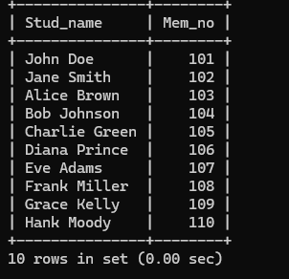

**Description:**

• **SELECT s.Stud_name, m.Mem_no**: Specifies the columns to retrieve, which are the student names (Stud_name) from the Student2 table and the membership numbers (Mem_no) from the Membership table.

• **FROM Student2 s**: Specifies the Student2 table as s (an alias for easier reference).

• **JOIN Membership m**: Joins the Membership table (aliased as m) with Student2.

• **ON s.Stud_no = m.Stud_no**: Specifies the condition that the Stud_no column in both tables must match for the rows to be joined.

this command joins the Student2 and Membership tables based on the student number (Stud_no) and retrieves the matching student names and membership numbers.

**D. List All the Issues for the Current Date with Student and Book Names**

SELECT s.Stud_name, b.book_name, i.iss_date FROM Iss_rec i JOIN Membership m ON i.Mem_no = m.Mem_no JOIN student2 s ON m.Stud_no = s.Stud_no JOIN Book b ON i.book_no = b.book_no WHERE i.iss_date = CURDATE();

**Output:**

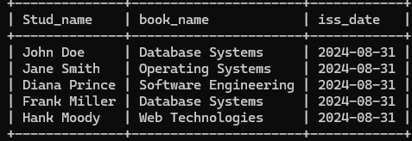

**Description:**

This query provides a list of students, the books they have issued, and the issue date, but only for those records where the books were issued today.

E. List the Details of Students Who Borrowed a Book Whose Author is CJDATE

SELECT s.Stud_name, b.book_name, b.author FROM Iss_rec i JOIN Membership m ON i.Mem_no = m.Mem_no JOIN Student2 s ON m.Stud_no = s.Stud_no JOIN Book b ON i.book_no = b.book_no WHERE b.author = 'CJDATE';

Output:

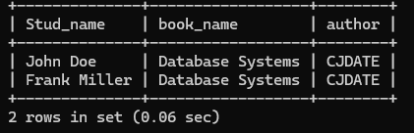

**Description:**

This query lists the names of students, the titles of the books they borrowed, and the author, specifically for books written by "CJDATE."

**F. Give a Count of How Many Books Have Been Borrowed by Each Student**

SELECT s.Stud_name, COUNT(i.book_no) AS books_borrowed FROM Iss_rec i JOIN Membership m ON i.Mem_no = m.Mem_no JOIN Student2 s ON m.Stud_no = s.Stud_no GROUP BY s.Stud_name;

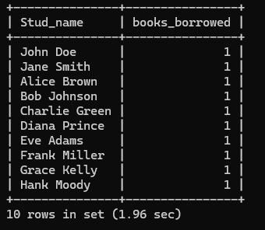

**Description:**

This query provides a list of students along with the total number of books they have borrowed, grouping the results by each student's name.

**G.Give a List of Books Taken by Student with Stud_no = 5**

SELECT b.book_name FROM Iss_rec i JOIN Membership m ON i.Mem_no = m.Mem_no JOIN Book b ON i.book_no = b.book_no WHERE m.Stud_no = 5;

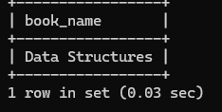

**Description:**

This query lists all the books that have been borrowed by the student whose student number is 5.

H. List the Book Details Which Are Issued as of Today

SELECT b.book_no, b.book_name, b.author FROM Iss_rec i JOIN Book b ON i.book_no = b.book_no WHERE i.iss_date = CURDATE();

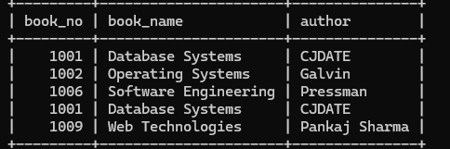

**Description:**

This query lists the book numbers, names, and authors of books that were issued today.

I. Create a View Which Lists Out the iss_no, iss_date, Stud_name, and book_name.

CREATE VIEW IssueDetails AS SELECT i.iss_no, i.iss_date, s.Stud_name, b.book_name FROM Iss_rec i JOIN Membership m ON i.Mem_no = m.Mem_no JOIN Student2 s ON m.Stud_no = s.Stud_no JOIN Book b ON i.book_no = b.book_no;



Description

This command creates a view that consolidates information about book issues, displaying the issue number, issue date, student names, and book names, allowing for simplified access to this combined data in future queries.

J.Create a View Which Lists the Daily Issues Date-Wise for the Last One Week

CREATE VIEW WeeklyIssues AS SELECT i.iss_date, s.Stud_name, b.book_name FROM Iss_rec i JOIN Membership m ON i.Mem_no = m.Mem_no JOIN Student2 s ON m.Stud_no = s.Stud_no JOIN Book b ON i.book_no = b.book_no WHERE i.iss_date >= CURDATE() - INTERVAL 7 DAY ORDER BY i.iss_date;



In SQL, tables store and persist data, while views provide a simplified way to access data from one or more tables. **A key difference is that tables physically store data, while views are virtual tables that don't require physical storage.**

**A foreign key is a column or group of columns that links data in two tables, while a join is a way to access data from multiple tables based on logical relationships:**

1. **Database Schema for a Employee-payscenario**

Employee (**emp_id:**integer,emp_name:string)

Department (**dept_id:integer**,dept_name:string)

Pay details (**emp_id : integer**,**dept_id: integer**, basic: integer, deductions: integer, additions: integer, DOJ: date)

Payroll **(emp_id : integer**, pay_date: date)

For the above schema, perform the following.

**A.** Create the tables with the appropriate integrity constraints.

**CREATE TABLE Department (**

**dept_id INT PRIMARY KEY,**

**dept_name VARCHAR(50) NOT NULL UNIQUE**

**);**

**CREATE TABLE Employee1 (**

**emp_id INT PRIMARY KEY,**

**emp_name VARCHAR(100) NOT NULL**

**);**

**CREATE TABLE Pay_Details (**

**emp_id INT,**

**dept_id INT,**

**basic INT CHECK (basic > 0),**

**deductions INT DEFAULT 0,**

**additions INT DEFAULT 0,**

**DOJ DATE,**

**PRIMARY KEY (emp_id, dept_id),**

**FOREIGN KEY (emp_id) REFERENCES Employee1(emp_id) ON DELETE CASCADE,**

**FOREIGN KEY (dept_id) REFERENCES Department(dept_id) ON DELETE CASCADE**

**);**

**CREATE TABLE Payroll (**

**emp_id INT,**

**pay_date DATE,**

**PRIMARY KEY (emp_id, pay_date),**

**FOREIGN KEY (emp_id) REFERENCES Employee1(emp_id) ON DELETE CASCADE**

**);**

**B.** Insert around 10 records in each of the tables.

**INSERT INTO Department VALUES**

**(1, 'HR'),**

**(2, 'Finance'),**

**(3, 'IT'),**

**(4, 'Sales'),**

**(5, 'Marketing');**

**INSERT INTO Employee1 VALUES**

**(1, 'Koushi'),**

**(2, 'Meghana'),**

**(3, 'Srinidhi'),**

**(4, 'Vainavi'),**

**(5, 'Akshaya'),**

**(6, 'Kavya'),**

**(7, 'Snehil'),**

**(8, 'Akshith'),**

**(9, 'Rishith'),**

**(10, 'Pratheesh');**

**INSERT INTO Pay_Details VALUES**

**(1, 1, 45000, 2000, 5000, '2022-03-10'),**

**(2, 2, 60000, 5000, 10000, '2021-08-15'),**

**(3, 3, 80000, 4000, 8000, '2023-01-05'),**

**(4, 1, 52000, 3000, 7000, '2022-11-20'),**

**(5, 2, 120000, 10000, 15000, '2020-07-01'),**

**(6, 3, 95000, 8000, 5000, '2021-09-12'),**

**(7, 4, 40000, 2000, 3000, '2023-06-18'),**

**(8, 4, 70000, 5000, 4000, '2022-12-22'),**

**(9, 5, 85000, 7000, 6000, '2023-02-10'),**

**(10, 5, 50000, 3000, 2000, '2021-05-25');**

**INSERT INTO Payroll VALUES**

**(1, '2023-12-31'),**

**(2, '2023-12-31'),**

**(3, '2023-12-31'),**

**(4, '2023-12-31'),**

**(5, '2023-12-31'),**

**(6, '2023-12-31'),**

**(7, '2023-12-31'),**

**(8, '2023-12-31'),**

**(9, '2023-12-31'),**

**(10, '2023-12-31');**

**C.** List the employee details department wise.

**SELECT e.emp_id, e.emp_name, d.dept_name**

**FROM Employee1 e**

**JOIN Pay_Details p ON e.emp_id = p.emp_id**

**JOIN Department d ON p.dept_id = d.dept_id**

**ORDER BY d.dept_name;**

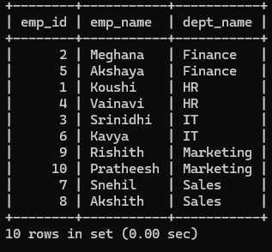

**D.** List all the employee names who joined after particular date.

**SELECT e.emp_name, p.DOJ**

**FROM Employee1 e**

**JOIN Pay_Details p ON e.emp_id = p.emp_id**

**WHERE p.DOJ > '2022-01-01';**

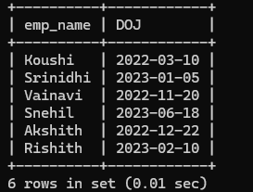

**e.** List the details of employees whose basic salary is between 50,000 and 1,00,000

**SELECT e.emp_name, p.basic**

**FROM Employee1 e**

**JOIN Pay_Details p ON e.emp_id = p.emp_id**

**WHERE p.basic BETWEEN 50000 AND 100000;**

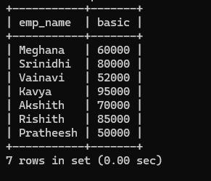

**f.** Give a count of how many employees are working in each department.

**SELECT d.dept_name, COUNT(*) AS emp_count**

**FROM Department d**

**JOIN Pay_Details p ON d.dept_id = p.dept_id**

**GROUP BY d.dept_name;**

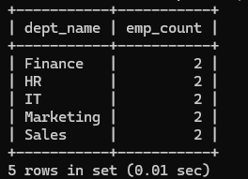

**g.** Give a name of the employees whose net salary>1,00,000.

SELECT e.emp_name,

(p.basic + p.additions - p.deductions) AS net_salary

FROM Employee1 e

JOIN Pay_Details p ON e.emp_id = p.emp_id

WHERE (p.basic + p.additions - p.deductions) > 100000;

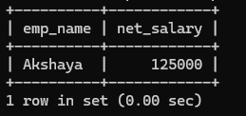

**h.** List the details for an employee_id=5

**SELECT e.emp_id, e.emp_name, d.dept_name, p.basic, p.additions, p.deductions, p.DOJ**

**FROM Employee1 e**

**JOIN Pay_Details p ON e.emp_id = p.emp_id**

**JOIN Department d ON p.dept_id = d.dept_id**

**WHERE e.emp_id = 5;**

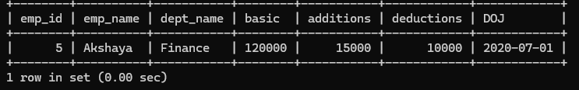

**i.** Create a view which lists out the emp_name, department, basic, deductions, net salary.

**CREATE VIEW Employee1_Salary_View AS**

**SELECT e.emp_name, d.dept_name, p.basic, p.deductions,**

**(p.basic + p.additions - p.deductions) AS net_salary**

**FROM Employee1 e**

**JOIN Pay_Details p ON e.emp_id = p.emp_id**

**JOIN Department d ON p.dept_id = d.dept_id;**

**CREATE VIEW Employee_Salary_View AS**

**SELECT e.emp_name, d.dept_name, p.basic, p.deductions,**

**(p.basic + p.additions - p.deductions) AS net_salary**

**FROM Employee e**

**JOIN Pay_Details p ON e.emp_id = p.emp_id**

**JOIN Department d ON p.dept_id = d.dept_id;**